8 Puzzle Problem Using Python
Aim
To solve the 8 Puzzle Problem using Python.

Objective
To arrange the tiles in the correct order by moving the blank space until the goal state is reached.

Algorithm
- Define the initial puzzle state.
- Define the goal state.
- Find the position of the blank tile (0).
- Move the blank tile in possible directions (Up, Down, Left, Right).
- Generate the next possible states.
- Repeat until the goal state is reached.
- Display the solution.

Flowchart
Start
|
v
Input Initial State
|
v
Compare with Goal State
/ \
Yes No
| |
Print Solution Generate
| Possible Moves
| |
+------<--------+
|
v
Stop

Code
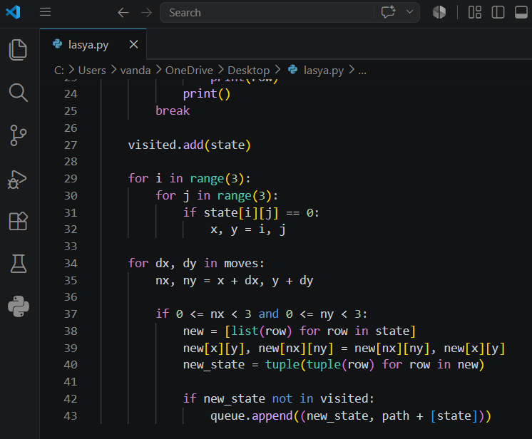
Output

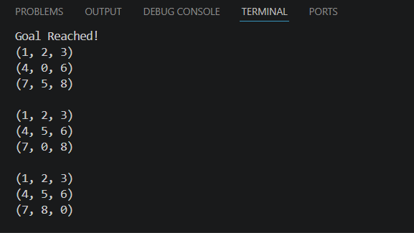
Result
The 8 Puzzle Problem was solved successfully, and the goal state was reached using Python.

Conclusion
The program demonstrates how the 8 Puzzle Problem can be solved by generating valid moves until the goal state is achieved. This illustrates the basic concept of state-space search in Artificial Intelligence.

